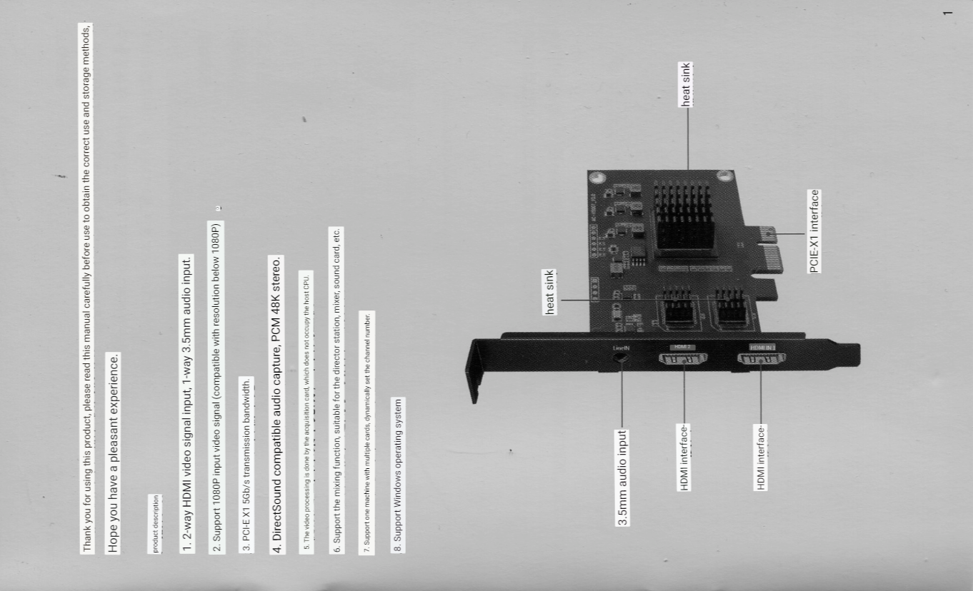

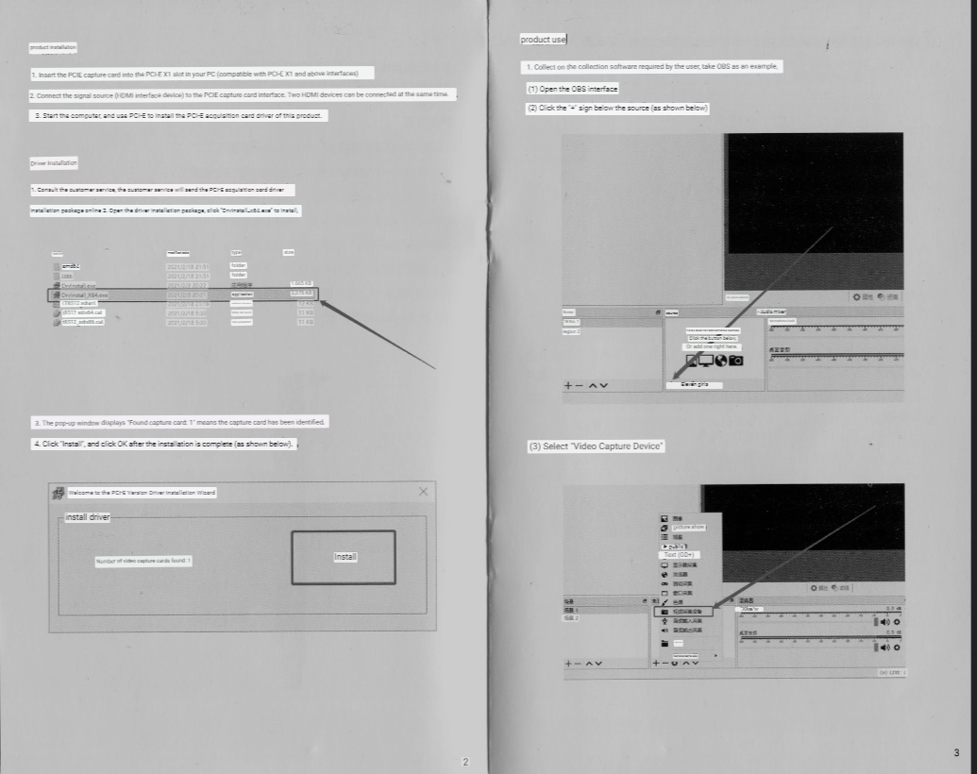

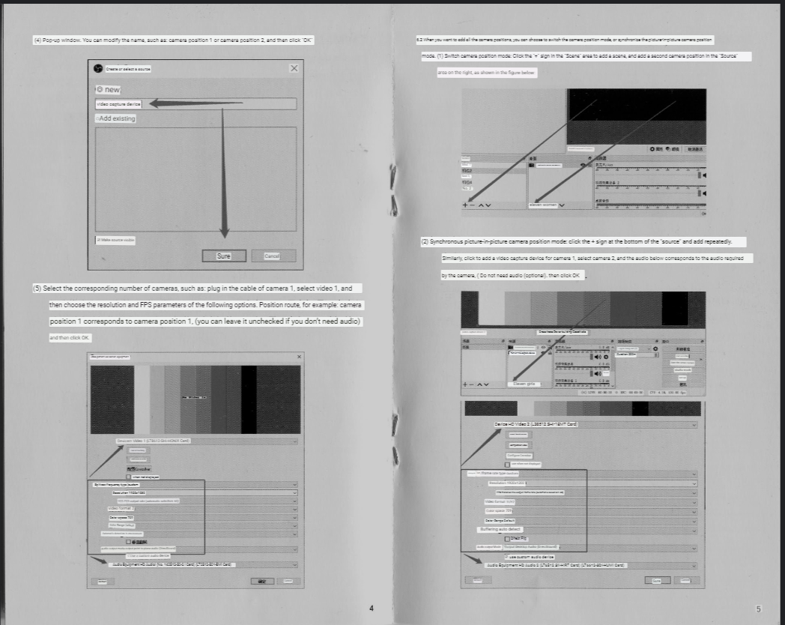

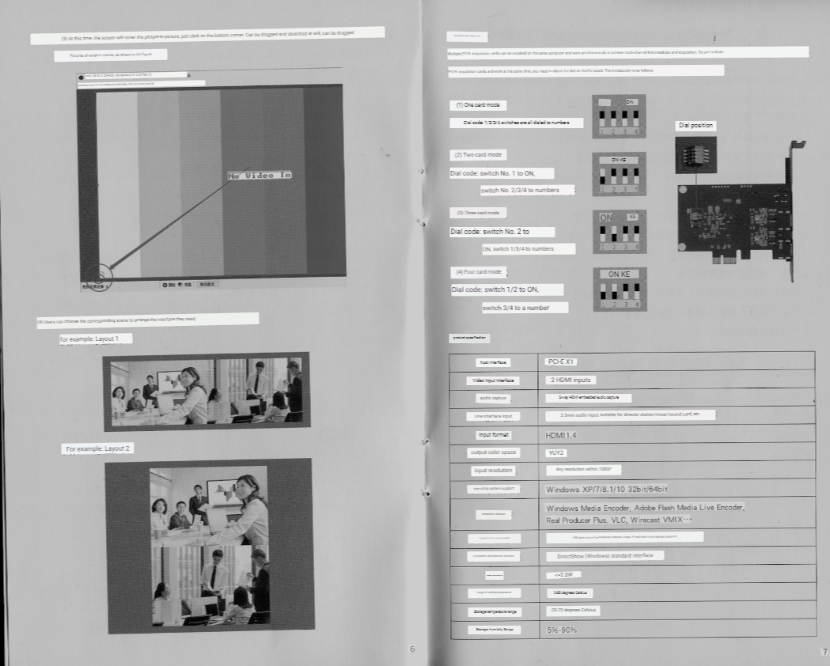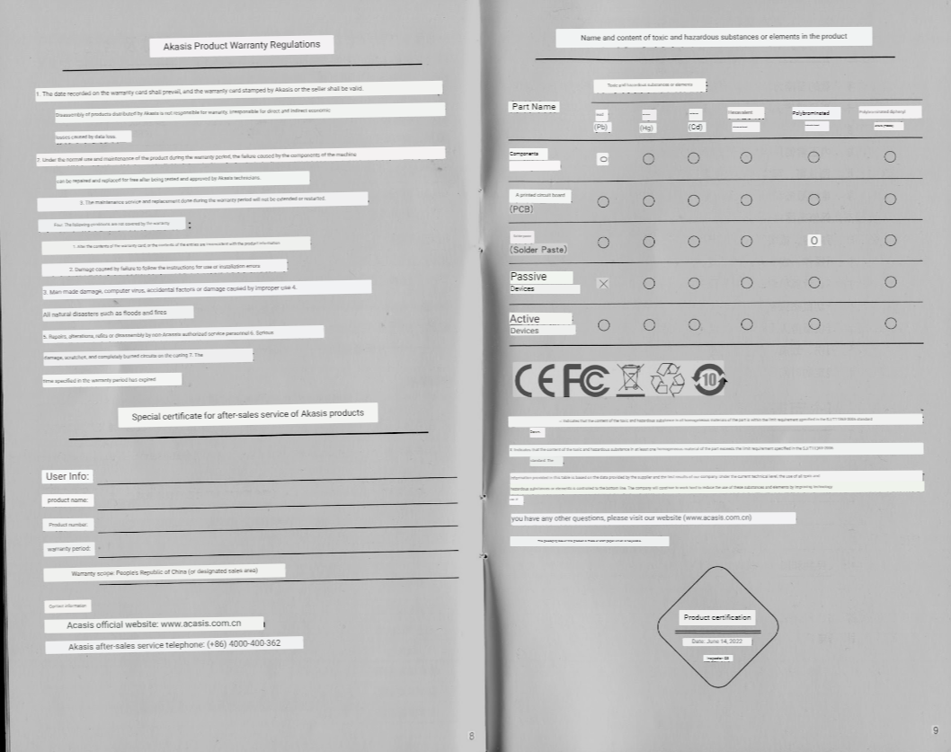

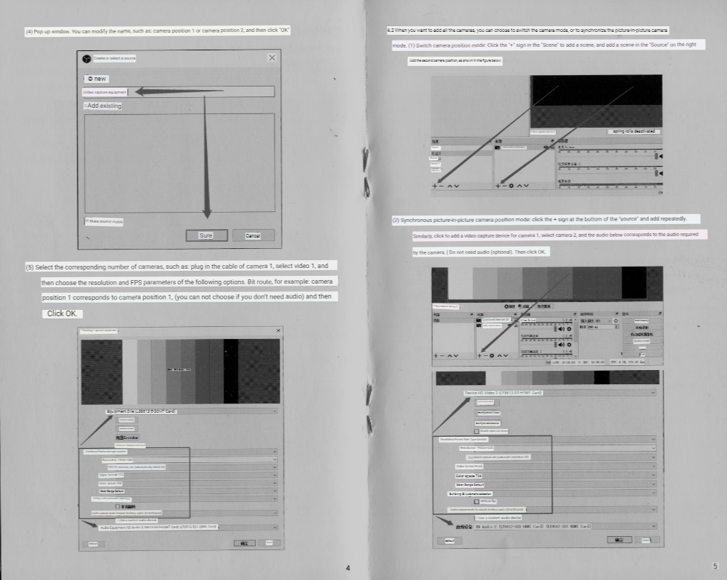

P1

Thank you for using this product, please read this manual carefully before use to obtain the correct use and storage methods,

Hope you have a pleasant experience.

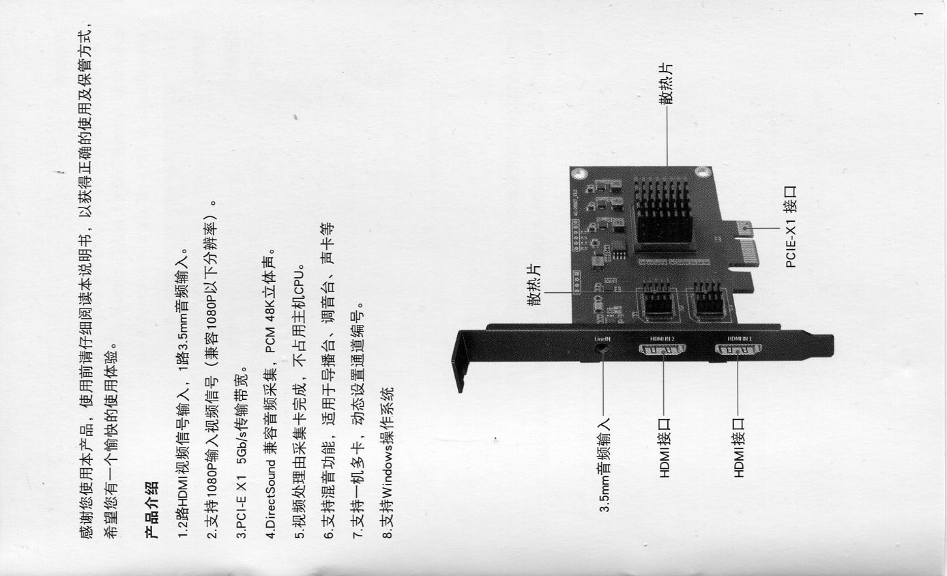product description

1. 2-way HDMI video signal input, 1-way 3.5mm audio input.

2. Support 1080P input video signal (compatible with resolution below 1080P)

3. PCI-E X1 5Gb/s transmission bandwidth.

4. DirectSound compatible audio capture, PCM 48K stereo.

5. The video processing is done by the acquisition card, which does not occupy the host CPU.

6. Support the mixing function, suitable for the director station, mixer, sound card, etc.

7. Support one machine with multiple cards, dynamically set the channel number.

8. Support Windows operating system

* heat sink
* 3.5mm audio input
* HDMI interface-
* HDMI 2
* heat sink
* HDMI interface-
* HDMI IN J
* PCIE-X1 interface

P2

## product installation

1. Insert the PCIE capture card into the PCI-E X1 slot in your PC (compatible with PCI-E X1 and above interfaces) 2. Connect the signal source (HDMI interface device) to the PCIE capture card interface. Two HDMI devices can be connected at the same time. 3. Start the computer, and use PCI-E to install the PCI-E acquisition card driver of this product.

Driver Installation

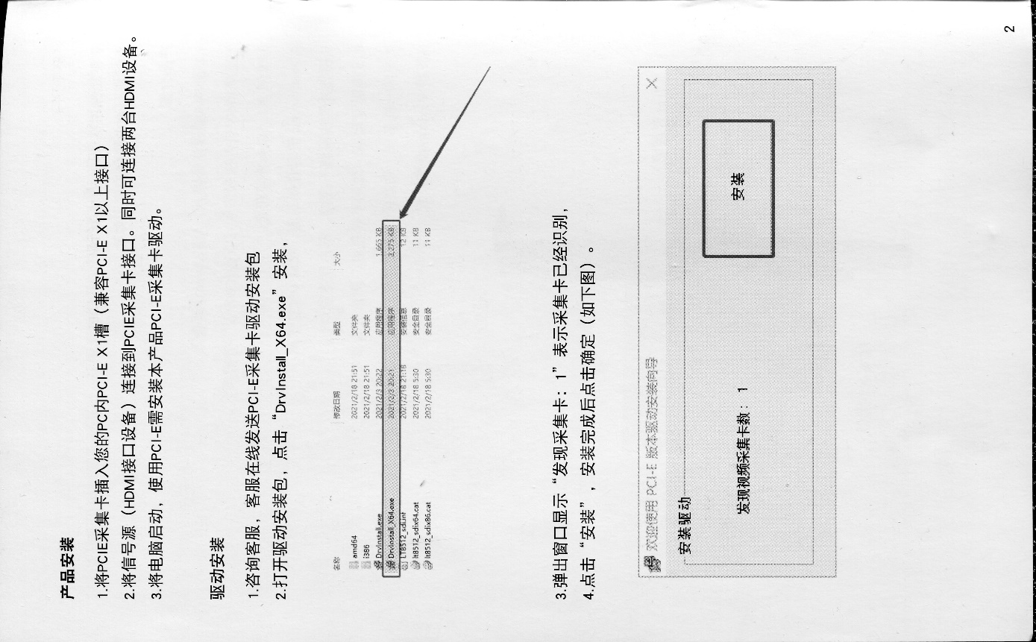1. Consult customer service, customer service will send PCI-E acquisition card driver installation package online 2. Open the driver installation package, click "DrvInstall_x64.exe" to install,

3. The pop-up window displays "Discover capture card: 1", indicating that the capture card has been recognized, 4. Click "Install", and click OK after the installation is complete (as shown below)

Welcome to the PCI-E Version Driver Installation Wizard

install driver

Number of found video capture cards: 1

Install

P3

## product use

1. Collect on the collection software required by the user, take OBS as an example,

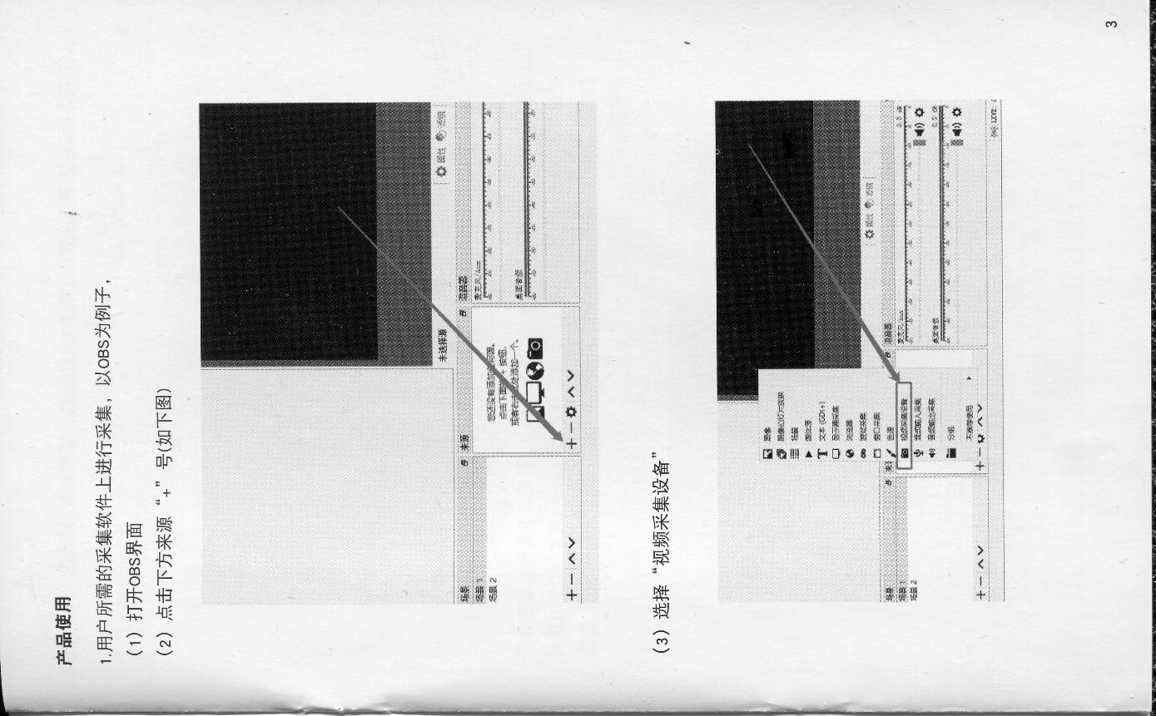( (2) Click the "+" sign below the source (as shown below)

1) Open the OBS interface

no source selected

Scene Scene 1 Scene 2

source

# Mixer Mic/Rum

You haven't added make homology. Click the + button below,

Or add one right here.

+1>ㄑ

(3) Select "Video Capture Device"

Tx (GDI+)

★Sex taste

Come

mixer:

Scene 1: 522

video capture device

) Baiwuwei out collection

salt grouping

Not allowed to use

LIVE:

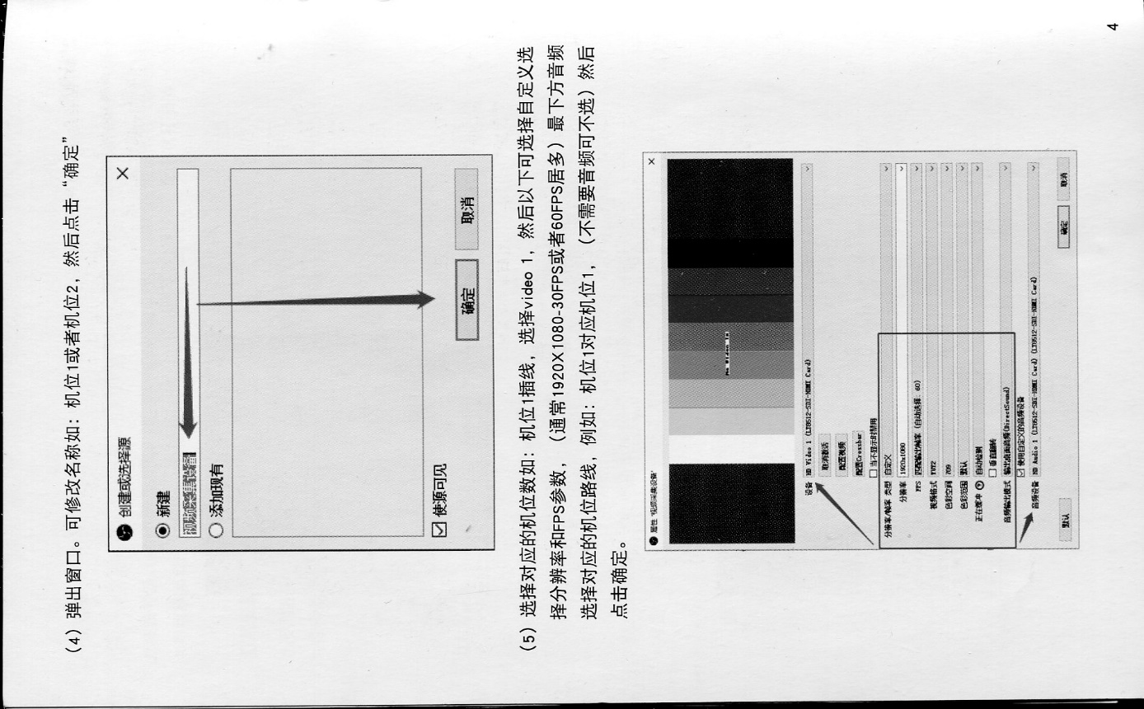P4

(4) Pop-up window. You can modify the name, such as: camera position 1 or camera position 2, and then click "OK"

Create a new capture device.

(5) Select the corresponding number of cameras, such as: plug in the cable of camera 1, select video 1, and then choose the resolution and FPS parameters of the following options. Bit route, for example: camera position 1 corresponds to camera position 1, (you can not choose if you don’t need audio) and then

Click OK.

• See Video Capture Devices

Device HD Video 1 (LT8612-SHI-HIMT Card)

Cancel counting

configuration video

Configure Crossbar)

use when not displayed

Resolution/Frame Rate Type Custom

Resolution 1920x1080

PS matching output frequency (automatic selection: 60)

Video format UY2

Color space 709

Color Range Default

Buffering auto detect

vertical

Audio output mode Output desktop audio (DirectSound)

√ Use a custom audio device

Audio device Hu Audio 1 (L.T8612-SB1EMI Card) (LT8512-52T-BM1 Card)

default

confirm cancellation

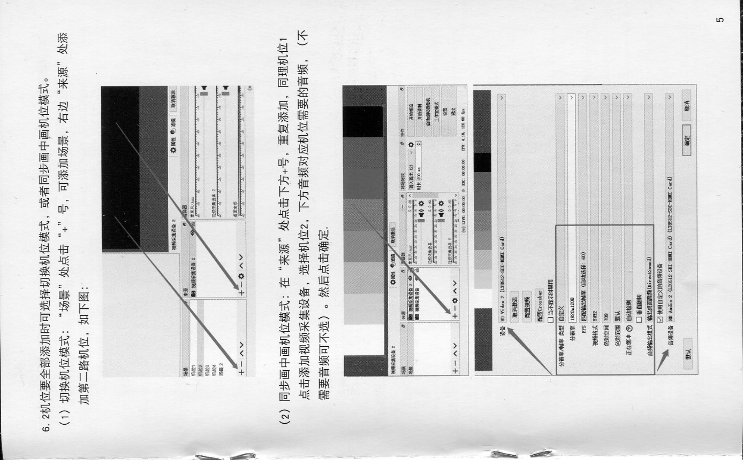P5

6.2 When you want to add all the cameras, you can choose to switch the camera mode, or to synchronize the picture-in-picture camera mode. (1) Switch machine mode: Click the "+" sign at the "Scene" to add a scene, and add a scene at the "Source" on the right

Add the second camera position, as shown in the figure below:

Video capture device 2

deactivate

source:

Scenes

Seat 1

video capture device 2

Camera 2 Camera 3 Camera 4 Field 2

Video capture device 2.

(2) Synchronous picture-in-picture camera position mode: click the + sign at the bottom of the "source" and add repeatedly. Similarly, click to add a video capture device for camera 1, select camera 2, and the audio below corresponds to the audio required by the camera.

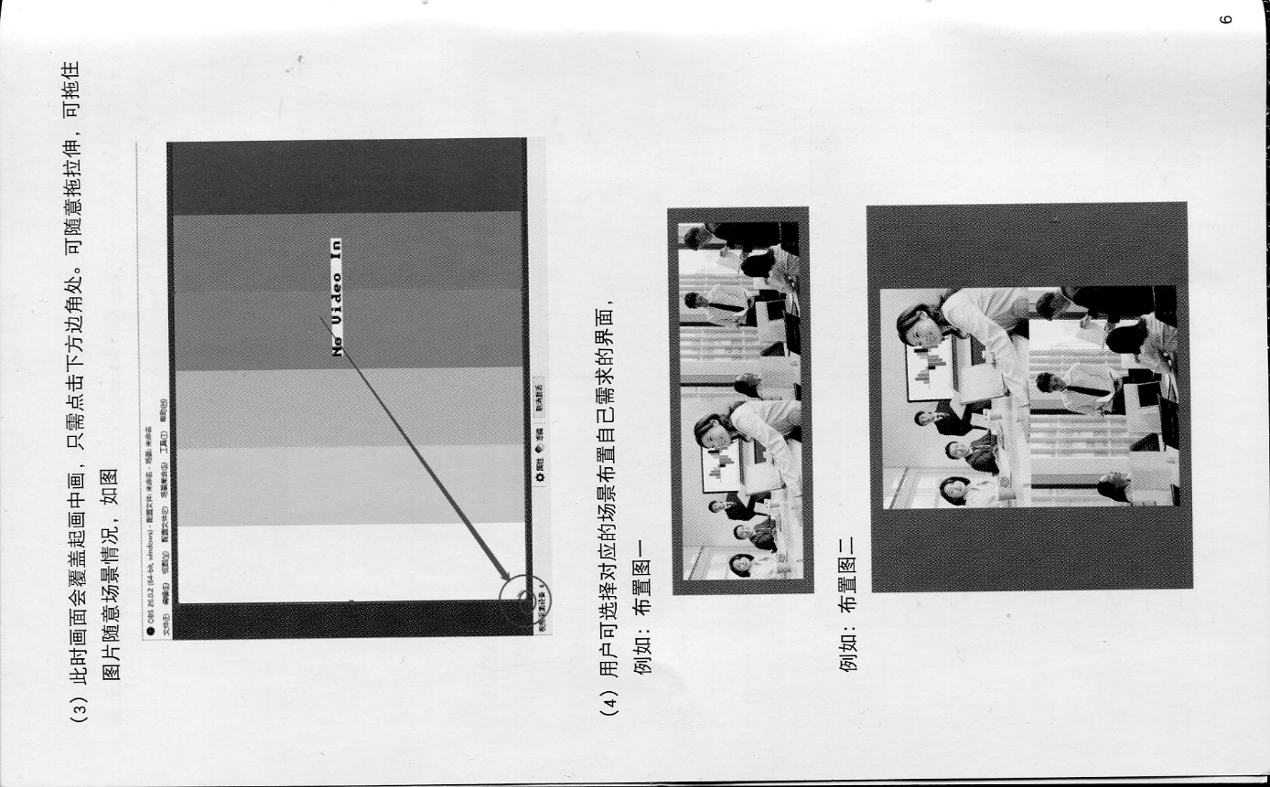P6

(3) At this time, the screen will cover the picture-in-picture, just click on the bottom corner. Can be dragged and stretched at will, can be dragged

Pictures of random scenes, as shown in the figure

OBS 25.0.2 (64-bit, windows)-Configuration file: Unranked, Field number: Weiyu Name: File Diagram City Store) Bowl Noodles Configuration File Record) Field Collection) Jianghuro Highlights

No Video In

(4) Users can choose the corresponding scene to arrange the interface they need,

For example: Layout One

For example: Layout 2

P7

## One machine with multiple cards

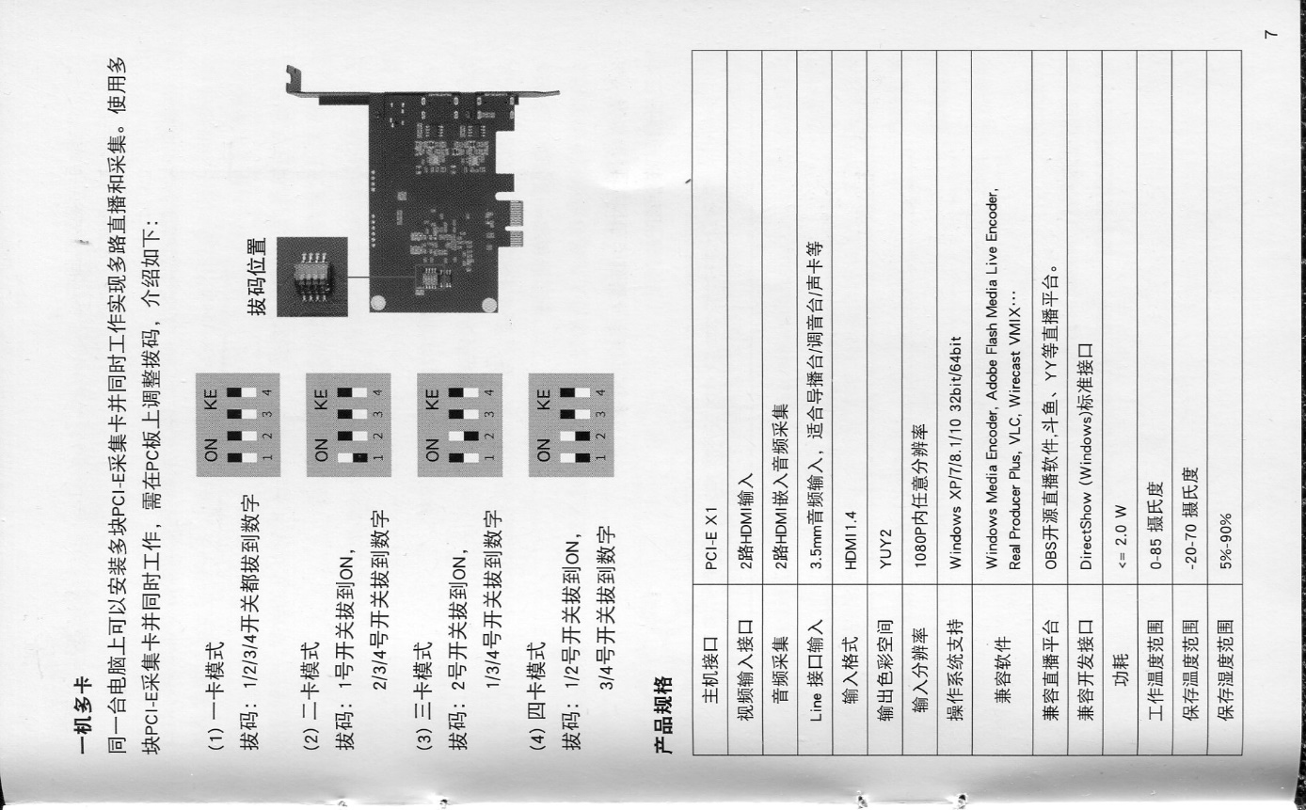Multiple PCI-E acquisition cards can be installed on the same computer and work simultaneously to achieve multi-channel live broadcast and acquisition. To use multiple PCI-E acquisition cards and work at the same time, you need to adjust the DIP switches.

(1) One card mode (switch tops are WHITE in images 🡪)

1/2/3/4 switches are all dialed to numbers

(2) Two-card mode

pull switch 1 to ON, Pull the 2/3/4 switch to the number

(3) Three-card mode

No. 2 switch is pulled to ON, Switch 1/3/4 to the number

(4) Four card mode

switch 1/2 to ON, switch 3/4 to a number

## product specification

host interface PCI-E X1

Video input interface Audio capture 2 HDMI inputs

2-way HDMI embedded audio capture Line interface input 3.5mm audio input.

input format HDMI1.4

output color space YUY2

input resolution Any resolution within 1080P

operating system support Windows XP/7/8.1/1032bit/64bit

compatible software Windows Media Encoder, Adobe Flash Media Live Encoder, Real Producer Plus, OBS , VLC, Wirecast VMIX...

Compatible development interface

DirectShow (Windows) standard interface

power consumption <=2.0W

range of working temperature 0-85 degrees Celsius

Storage temperature range -20-70 degrees Celsius

Storage Humidity Range 5%-90%

P8

## Akasis Product Warranty Regulations

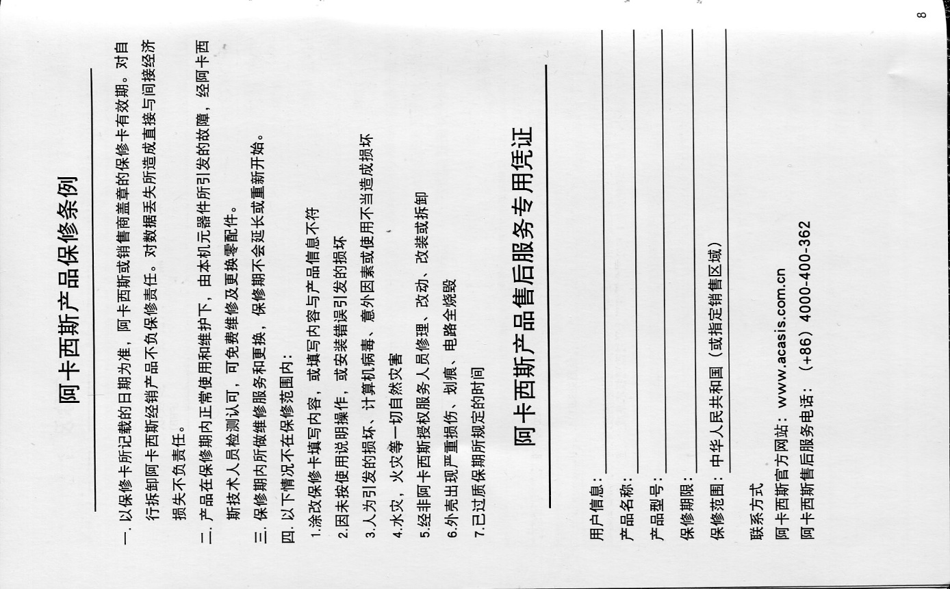1. Based on the date recorded in the warranty card, the validity period of the warranty card stamped by Akasis or the seller. Disassembly of products distributed by Akasis is not responsible for warranty. The direct and indirect economic impact of data loss

Irresponsible for losses.

2. Under the normal use and maintenance of the product during the warranty period, the failure caused by the components of the machine will be verified by Akaxi

Sri Lankan technical personnel testing and approval, can repair and replace spare parts for free.

3. The maintenance service and replacement done during the warranty period will not be extended or restarted.

Four. The following conditions are not covered by the warranty:

1. The content filled in the warranty card is altered, or the content is inconsistent with the product information 2. Damage caused by failure to follow the instructions for use or installation errors

3. Man-made damage, computer virus, accidental factors or damage caused by improper use

4. All natural disasters such as floods and fires

5. Repaired, modified, modified or disassembled by non-Acassis authorized service personnel

6. The casing has serious damage, scratches, and the circuit is completely burned

7. The time specified in the warranty period has passed

Special certificate for after-sales service of Akasis products

User Info:

product name:

Product Model: Warranty Period:

Warranty scope: People's Republic of China (or designated sales area)

Contact information

Acasis official website: www.acasis.com.cn Acasis after-sales service telephone: (+86) 4000-400-362

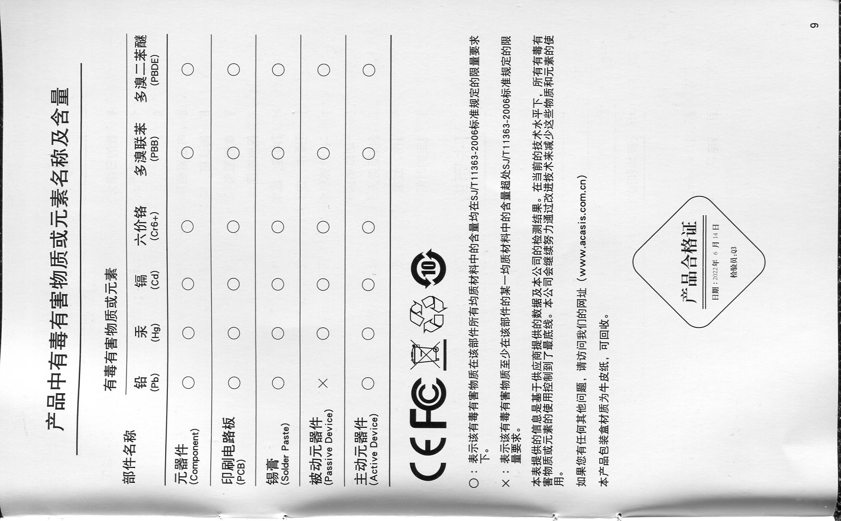P9

Name and content of toxic and hazardous substances or elements in the product

Toxic and hazardous substances or elements

Part Name

○: Indicates that the content of the toxic and hazardous substance in all homogeneous materials of the part is within the limit requirement specified in the SJ/T11363-2006 standard

X: Indicates that the content of the toxic and hazardous substance in at least one homogeneous material of the part exceeds the limit specified in the SJ/T11363-2006 standard

volume requirements.

The information provided in this table is based on the data provided by the supplier and the test results of our company. Under the current technical level, the use of all toxic and hazardous substances or elements is controlled to the bottom line. The company will continue to work hard to reduce the use of these substances and elements by improving technology

use.

If you have any other questions, please visit our website (www.acasis.com.cn)

The packaging box of this product is made of kraft paper, which is recyclable.

Product certification

Date: June 14, 2022 Inspector: Q3